***SANDROCK VILLA***

***SERVICES***

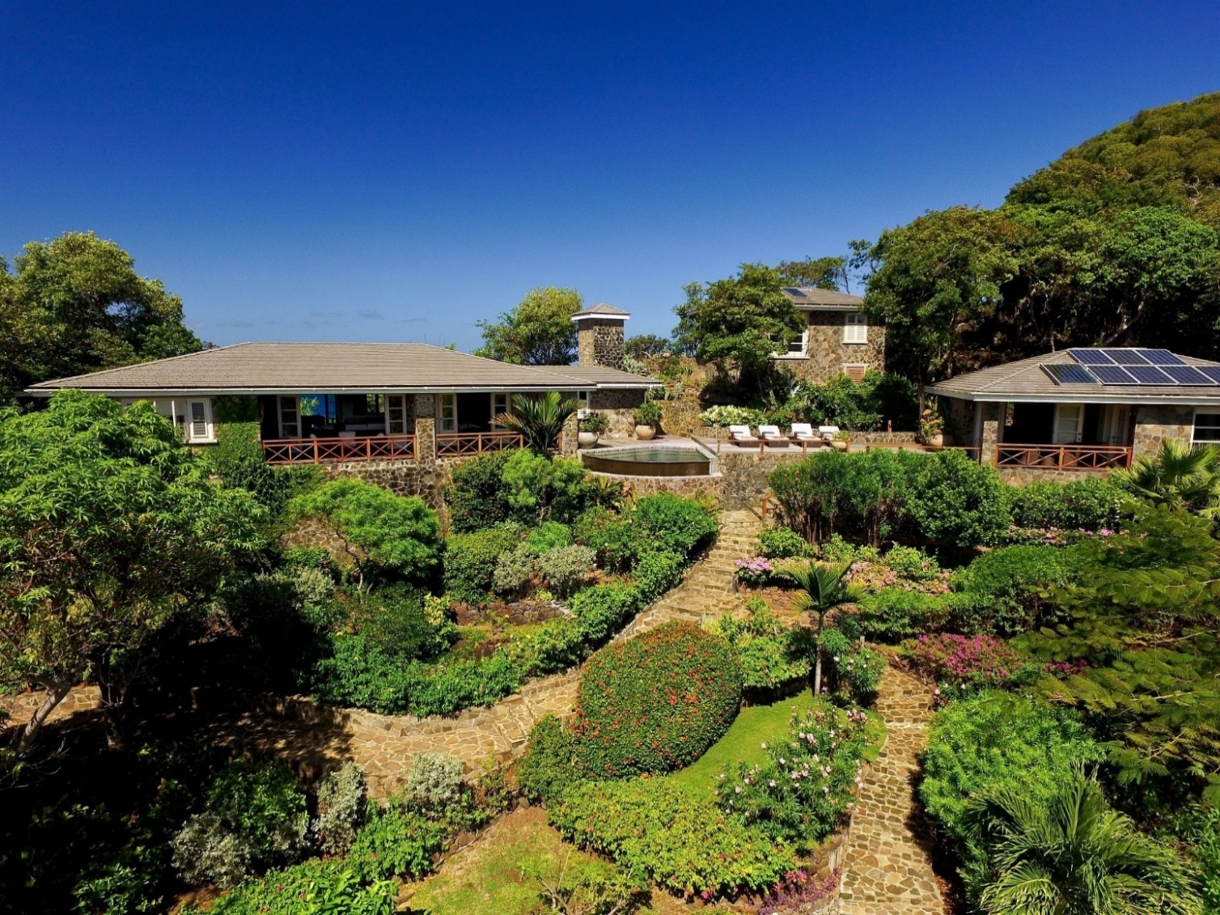



***LAUNDRY AND HOUSEKEEPING SERVICE (GUIDANCE ONLY)***

*Cleaning services to bedrooms and bathrooms will be 3 times a week.*

*(Tuesdays, Thursdays and Saturdays)*

*Bed sheets will be changed once weekly.*

*Bathroom and beach towels will be changed 2 times a week.*

*(****to conserve water as all water for washing is collected natural rainwater****).*

***ADDITIONAL CHANGES OF BED LINEN AND FRESH TOWELS ARE AVAILABLE IF REQUIRED.***

*Laundry service is available for smaller items of clothing – place them in the laundry baskets provided in your room and housekeeping will deliver them back to the lounge area.*

*Please speak to Matthew for instructions on how to use the washing machine for larger items.*

*On arrival sunbed cushions will be on the sunbeds and beach towels are provided.*

*If you require your rooms to be sprayed with insect repellent and the air conditioning switched on before you retire for the evening, please let Matthew know.*

***A GUIDE TO GRATUITIES FOR VILLA STAFF***

*It is common practice in the Caribbean to leave gratuities for staff.*

*If you feel you would like to leave a gratuity for the housekeeping staff, a guide is $US10- $US15 per day of your stay.*

*If you do not require Matthew to cook for you but would like to reward his service, a guide is UD$25-US$30 per day of your stay.*



***We are very pleased to help you in all aspects during your time with us at Sandrock and wish you a comfortable and pleasant stay.***

***If you need anything – please ask***

***Service fee for preparing all meals***

***MEALS CAN BE PREARRANGED DIRECTLY WITH MATTHEW IN ADVANCE OF YOUR STAY***

***2-4 GUESTS***

*Breakfast, lunch and dinner* ***200 USD***

*If only for dinner* ***100 USD****, only breakfast* ***50 USD****, only lunch* ***50USD***

***5-8 GUESTS*** *(to include an assistant for dinner)*

*Breakfast, lunch and dinner* ***250 USD***

*If only dinner* ***150 USD****, only breakfast* ***50 USD****, only lunch* ***50 USD***

***9-10 GUESTS*** *(to include an assistant for dinner)*

*Breakfast, lunch and dinner* ***300 USD***

*If only dinner* ***200 USD****, only breakfast* ***50 USD****, only lunch* ***50 USD***

***MEAL PREPERATION FEE TO BE PAID DIRECTLY TO MATTHEW***

***Shopping service fee***

*Please let Matthew know if you require any provisions, Matthew has good local knowledge of what provisions and services are available – please feel to ask him.*

***A FEE OF 10% OF THE VALUE OF GROCERIES TO BE PAID DIRECTLY TO MATTHEW***

***Thank you for choosing to stay at Sandrock Villa, enjoy your stay!***

***We hope you see you again***

